**The Making of a Reaction Game**

The script componentsrequired to make the reaction game are all required to be placed onto an “Empty Game Object”. This design allows for a clean code structure and the ability to edit specific features of the game with ease.

**Component 1: Input Manager**

The Input Manager allows for the game to detect the user’s input and trigger code because of an input.

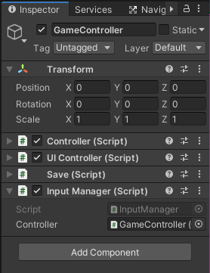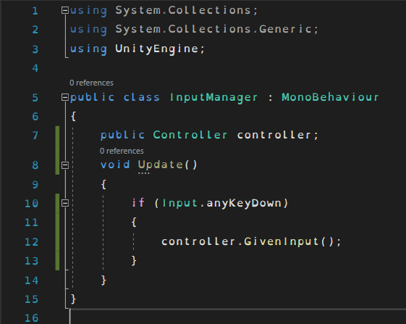

**Component 2: UI Controller**

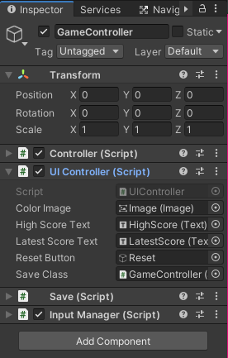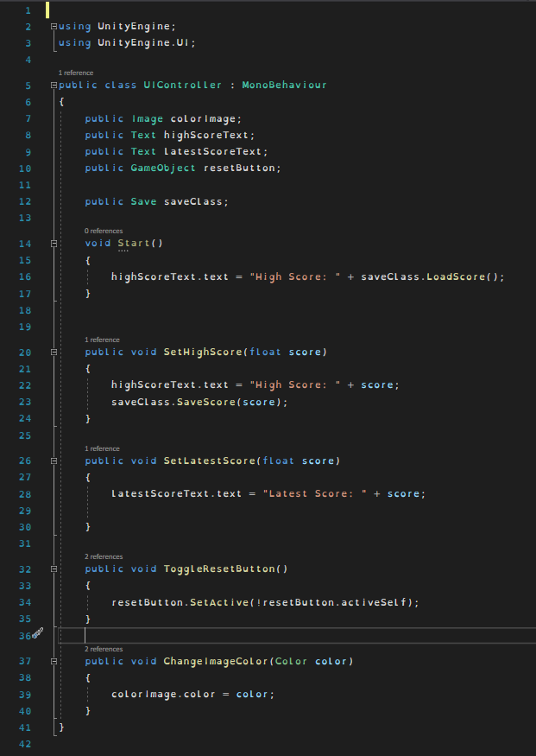The UI Controller allows all the UI elements in the scene to be controlled via methods that can be called from other scripts.

**Component 3: Game Controller**

The Game Controller component controls the game. This component will randomly set the colour of the image when it is to be clicked, measure the time it takes for the user to react to the colour change and then send the appropriate information to the UI Manager to update the game’s UI.

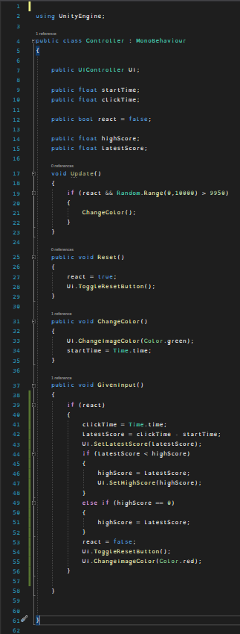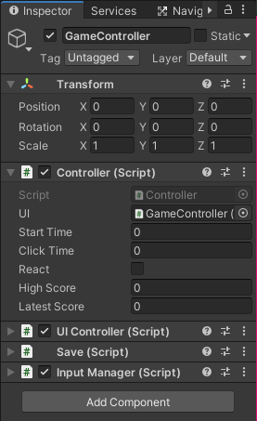

**Component 4: Save Manager**

The Save Manager allows for player’s high score to be saved and loaded. When a new high score is recorded the Game Controller triggers the Save Manager to set that float to the Player Prefs.

When the game is launched the Game Controller will attempt to load a saved high score from the Player Prefs via using the “LoadScore” method in the Save Manager.

